**Question 1**

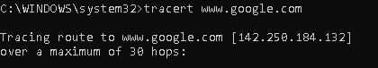

**Question 2**

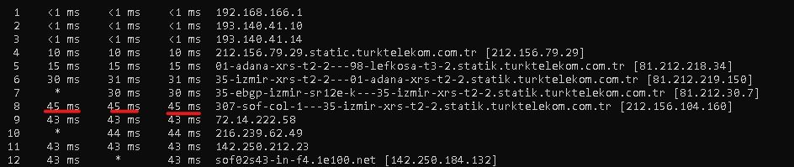

Question 3

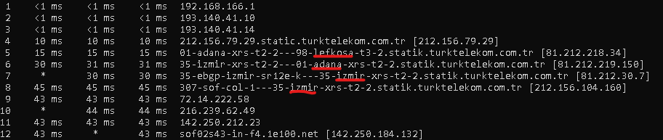

**Question 4**

Dns-admin.google.com

**Question 5**

Mx record

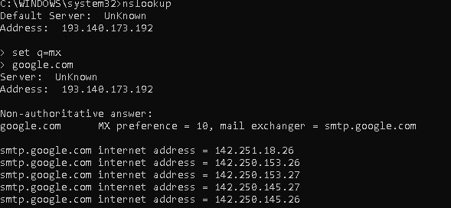

**Question 6**

